DB LAB 1 - 24K0546
– Q1: Display all employees whose salary is between 3000 and 7000.
SELECT * FROM employees WHERE salary BETWEEN 3000 AND 7000;
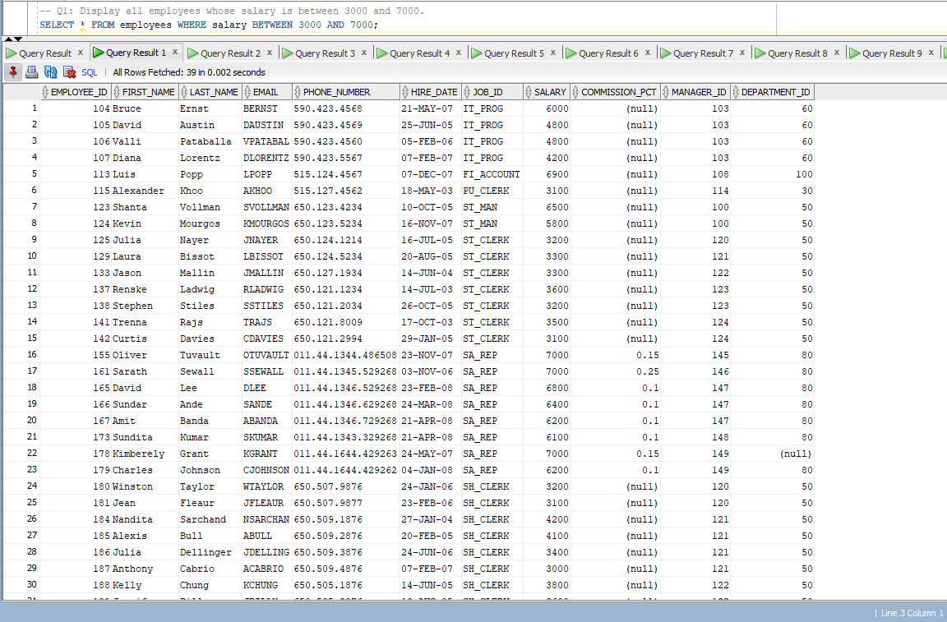

– Q2: Display all employees whose first_name starts with ‘A’.
SELECT * FROM employees WHERE first_name LIKE “A%”;
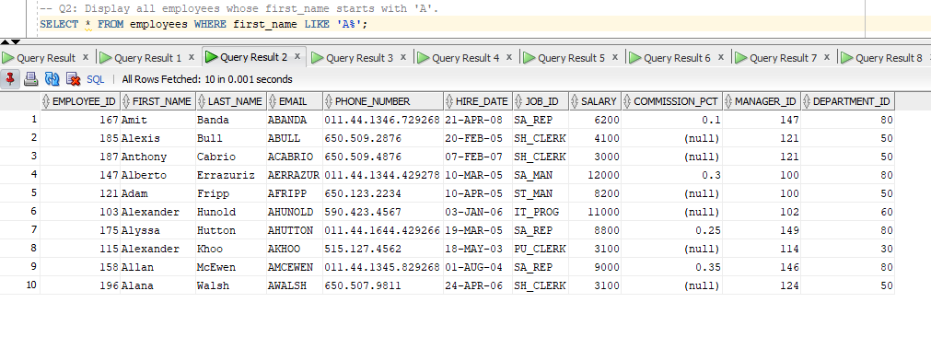

– Q3: Display all employees whose department_id is 50 OR 80.
SELECT * FROM employees WHERE department_id = 50 OR department_id = 80;
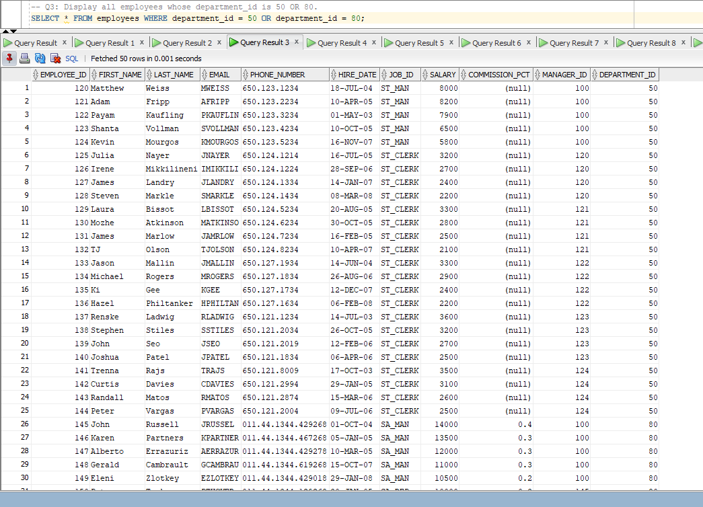

– Q4: Display all employees whose salary is greater than 5000 AND department_id is 60.
SELECT * FROM employees WHERE salary > 5000 AND department_id = 60;
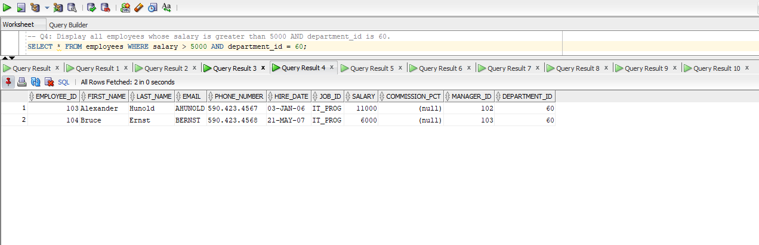

– Q5: Display all employees whose first_name does NOT start with ‘S’.
SELECT * FROM employees WHERE first_name NOT LIKE “S%”;
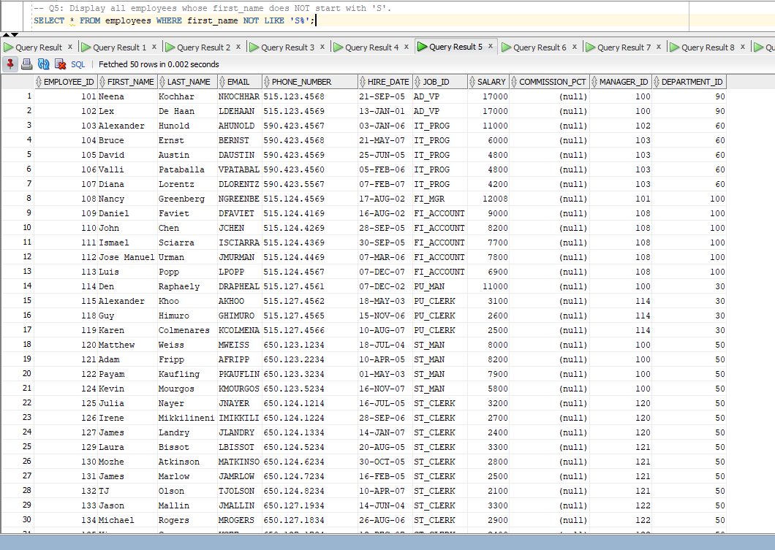

– Q6: Display all employees whose hire_date is between 01-JAN-2004 and 31-DEC-2008.
SELECT * FROM employees WHERE hire_date BETWEEN “2004-01-01” AND “2008-12-31”;
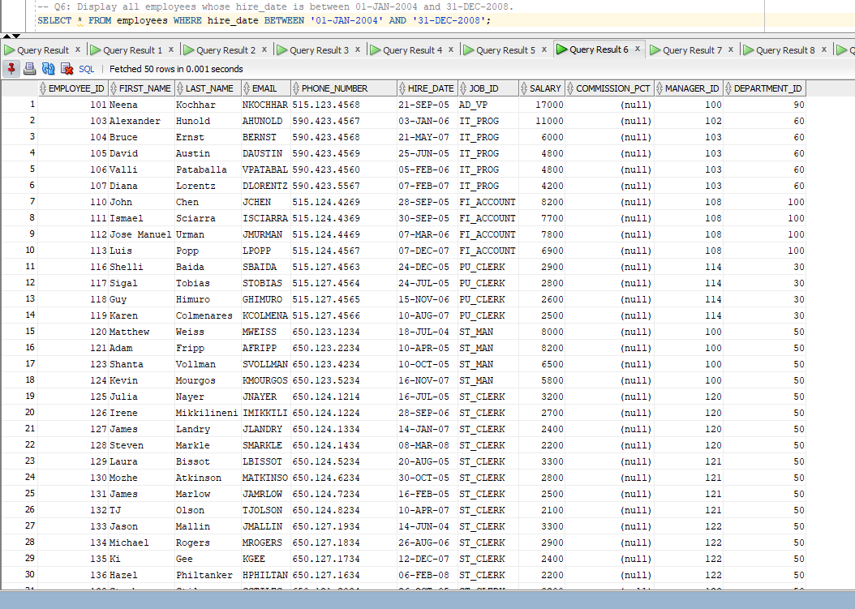
– Q7: Display all employees whose job_id is ‘IT_PROG’ OR salary is greater than 8000.
SELECT * FROM employees WHERE job_id = “IT_PROG” OR salary > 8000;
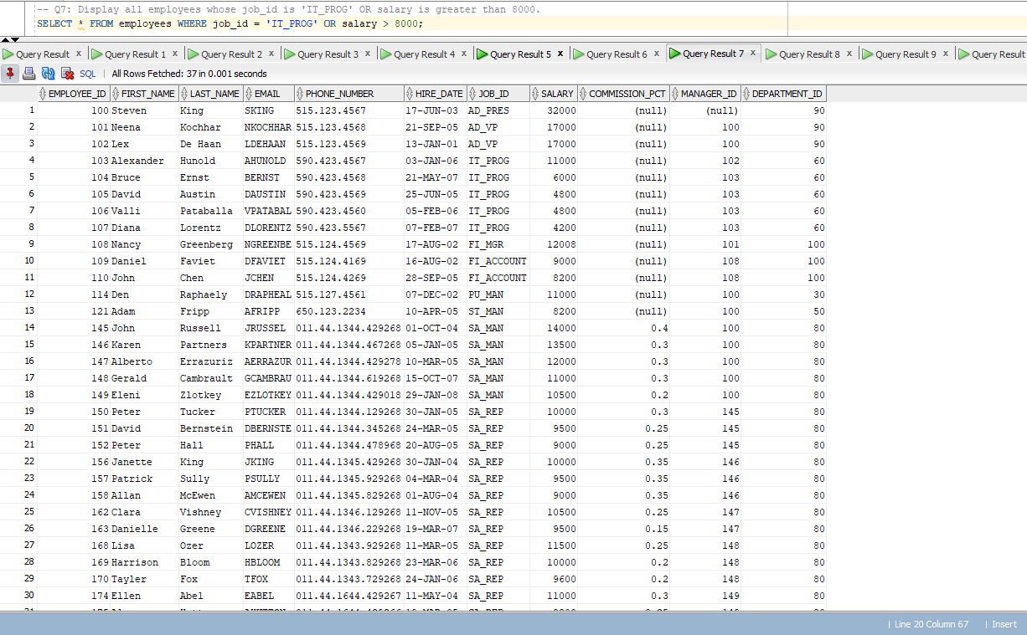

– Q8: Display all employees whose department_id is NOT between 30 and 90.
SELECT * FROM employees WHERE department_id < 30 OR department_id > 90;
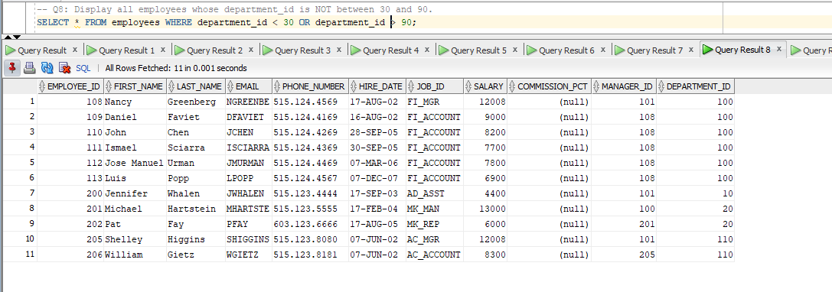

– Q9: Display all employees whose first_name contains ‘an’.
SELECT * FROM employees WHERE first_name LIKE “%an%”;
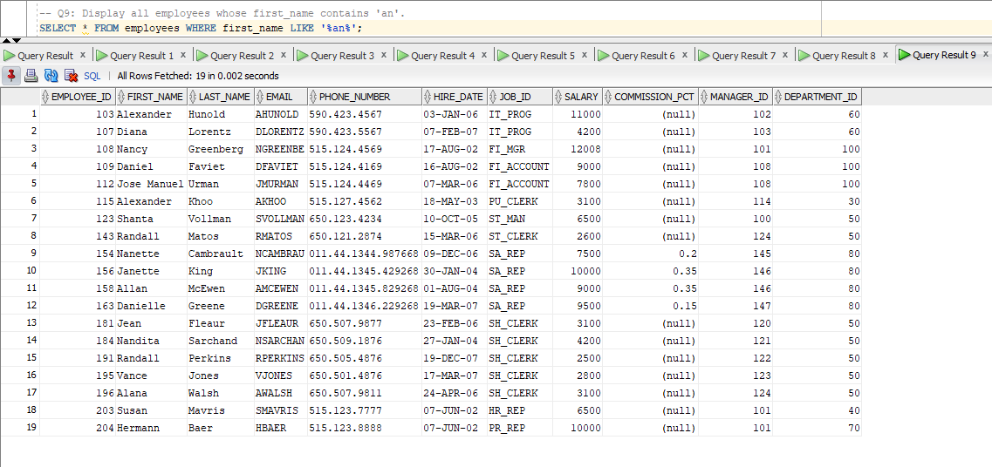

– Q10: Display all employees whose salary is less than 4000 AND first_name ends with ‘n’.
SELECT * FROM employees WHERE salary < 4000 AND first_name LIKE “%n”;
